HRC fuse TIS Dimenssion:
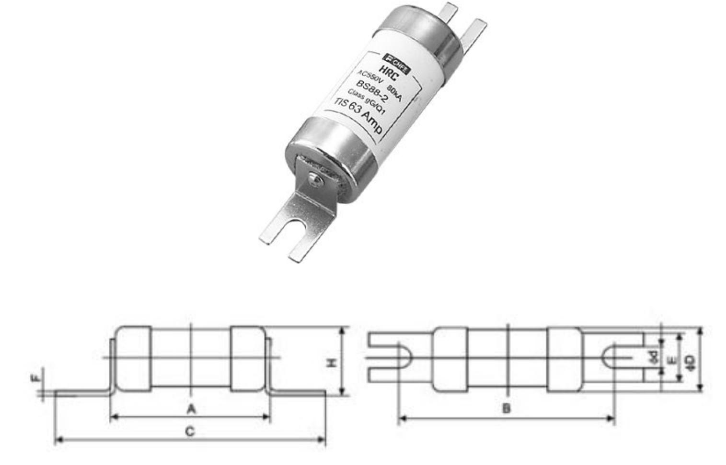

Item | Rated | Rated |  |  |  | Dimension(mm)
Item | voltage | current
 | voltage | current | A | B | C | ΦD | E | F | H | Фd
TIS | 550V | 40-100A | 56 | 75 | 87 | 21 | 13 | 1.0 | 24 | 5

